## CHERRY IN LINE

**Chapter 5**

**Findings, Results, and Analysis**

5.2.7 Grounding system

|  |  |  |  |  |  |  |
| --- | --- | --- | --- | --- | --- | --- |
| **GROUNDING RESISTANCE MEASUREMENT TEST** | | | | | | |
| **SUMMARY OF FINDNGS CHERRY INLINE STATION** | | | | | | |
|  | | | | | | |
| **LOCATION** | **EQUIPMENT NAME /ROOM** | **MEASURED GROUNDING RESISTANCE** | **FINDINGS** | **RECCOMMENDATIONS** | **EFFECTS** | **RISKS** |
| **IF NOT CORRECTED** | **(POSSIBLE OUTCOME)** |
| LIGHTNING ARRESTER POST | TEST POINT 1 BARE COPPER WIRE | 1.24 Ω | Within the 5 ohms limit as per NFPA and IEEE standards | (1)Check tightness of connection of BCW to Ground Rod  (2) Grounding system electrical and mechanical connections should be free of corrosion.  (3) Replace BCW for better conductivity. | None | None |
| MTS EQUIPMENT GROUND | TEST POINT 2 BARE COPPER WIRE | 7.2 V | Measured voltage in the bare copper wire | Check and trace where the voltage is coming from and correct the connection | Danger to personnel and damage to equipment if not immediately corrected | Health and safety risks for facilities and personnel and Damage to equipment or accessories |
| MTS EQUIPMENT GROUND | TEST POINT 2 GROUND ROD | 8.2 V | Same as MTS equipment | Same as MTS equipment | Same as MTS equipment | Same as MTS equipment |
| GENSET | TEST POINT 3 BARE COPPER WIRE | CAN’T MEASURE | CONNECTED TO GROUNDING BUSBAR OF MTS | Same as MTS equipment | (1) Unwanted voltage maybe present on non-current carrying metal objects (2) Equipment might be damaged during a fault condition | (1) Incorrect Operation of overcurrent device with ground fault protection (2) Health and safety risks for facilities and personnel |
| **BASIS:**  The resistance between the main grounding electrode and ground should be no greater than five ohms for large commercial or industrial systems and 1.0 ohm or less for generating or transmission station grounds unless otherwise specified by the owner. (Reference ANSI/IEEE Standard 142) | | | | | | |

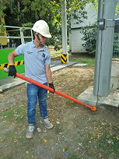 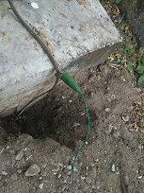 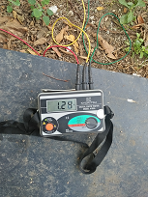

Voltage measurement-LA Post Bare copper wire of post Ground Resistance Measure

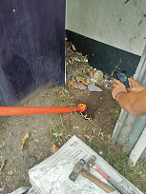 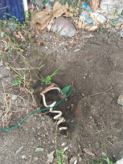 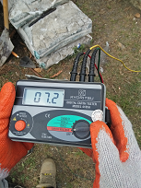 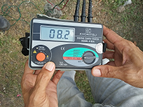

Voltage Measurement – MTS Connection to Ground Rod Measured Voltage on BCW Measured Voltage on Rod